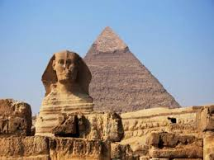
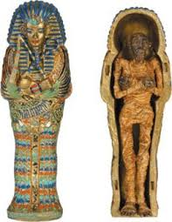
Topic: The Egyptians - Mummy Mania

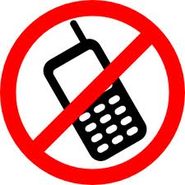
Task 1:
List 6 things that we would NOT see in Ancient Egypt and explain why.
AND
List 6 things that we WOULD see in Ancient Egypt and explain why.
Hand in Wednesday 16th January

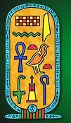Task 2:
Research the Ancient Egyptian hieroglyphic alphabet and write them out. Then create your own and use it to write your name.
Hand in Wednesday 23rd January

Task 3:
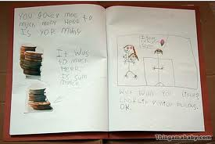
Create a fact file about Ancient Egypt. Think about the River Nile, the Pyramids, the gods, food and drink, their clothing and the houses.
Hand in Wednesday 30th January

Task 4:
Design and make a simple game about Ancient Egypt eg. snap, uno, snakes and ladders etc. List the rules of the game.
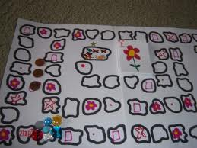
Hand in Wednesday 6th February

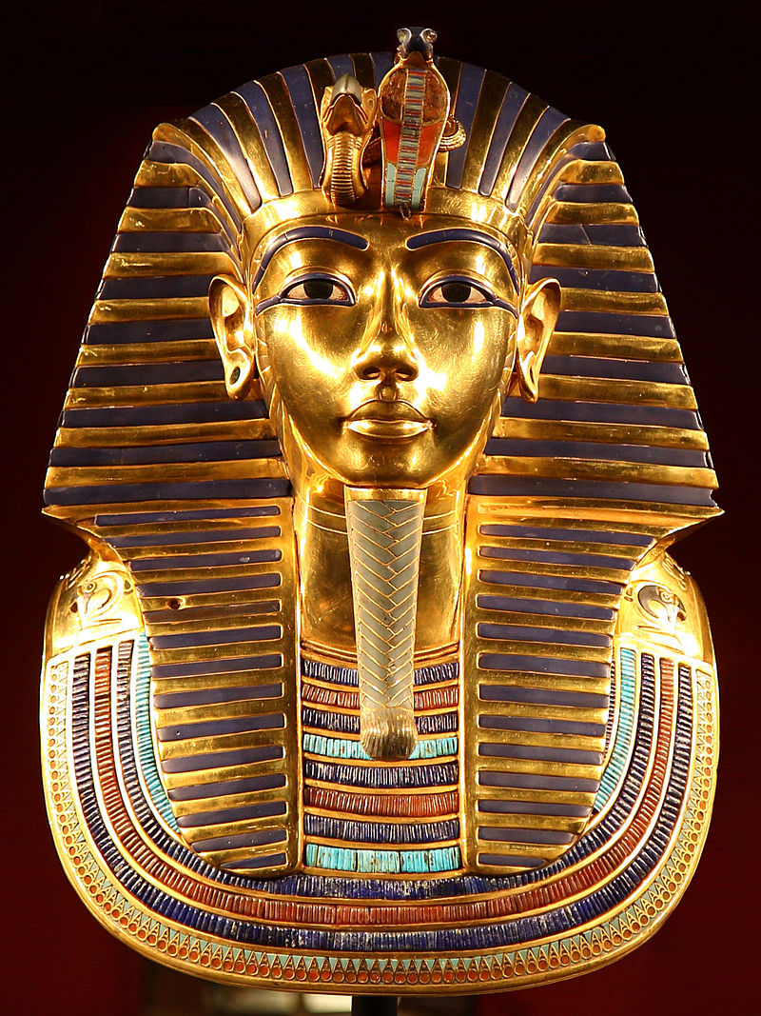
Task 5: Draw a diagram of Tutankhamun’s mask. Explain what was used to make the mask, how the mask was used, and where and when it was discovered.
Hand in Wednesday 13th February

