Year Group:3 Spring 2 The Victorians

History  As historians we want to know and remember…  We will know when the Victorian period started and ended. We will identify Queen Victoria.  We will compare and contrast our lives to Victorian children’s – jobs, schools, rich/ poor lifestyles and the workhouse.. We will learn about the industrial revolution and will develop our knowledge of inventions by looking at artefacts and discussing the impact of certain inventions.We will learn about at least one famous inventor and the development of their invention e.g Alexander Graham Bell.  Vocabulary:  Inventions  Poverty  Governess  Raggy schools  Corporal Punishment  Innovator  Engineer  We want to practice how to (do)  Skills  Use a range of source materials to ….  Compare everyday life then and now.  Experience/get a taste of Victorian Britain by visiting Beamish History Museum  Experience a what it was like to be a child at schoo and in the home during Victorian times  Look for clues around the local area of our Victorian heritage.  Talk about innovation and how an idea can develop and become global  Think like an inventor/innovator | Geography  History Focus this term  Continue to refer to map / globe / google earth when appropriate to reinforce links.  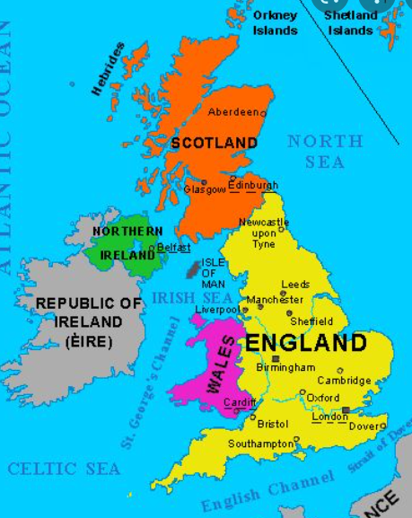 | Art and Design  As artists we will explore shape and tone  Knowledge and skills  - To find shapes in everyday objects  - - to draw from observation  - - to create form and shape using wire  - - to practise shading neatly from light to dark  - to bend and manipulate wire to make a sculpture  Vocabulary - geometric, shapes, tone, lines, light, dark, shading, wavy lines, 2D , 3D, wire, sculpture  In preparation for Beamish we will look at the work of Victorian artist William Morris and make links to our history topic. We will learn about repeating patterns, how his work was influenced by the countryside and why his work was so popular during the industrial revolution. We will use our skills to create wallpapers and use watercolours to create a design in his style for our mother’s day cards.
Music  As musicians we want to know and remember  Knowledge  To know how to play a tuned instrument and to know how to play chords.  To learn and appraise songs  To perform a song  To experience Music in Victorian times , music saloons , music hall  We want to practice how to (do)  Skills  Play tuned instruments (ukulele and glockenspiel) and follow notation.  Learn, appraise and perform songs  Perform to a live audience (Ukulele concert )  Vocabulary  Chords, play, stop, tempo, beat, strum,perform, sing, in time, rhythm count | Topic: The Victorians  Question driver:  What would it be like to go to school in Victorian Times ? Would you rather be at school then or now ?  Project\ purpose: Visit to Beamish - Living History Museum take part in classroom workshop.  Local study - Heritage Trail around Monkseaton / whitley Bay Tynemouth looking at features / things from Victorian time.  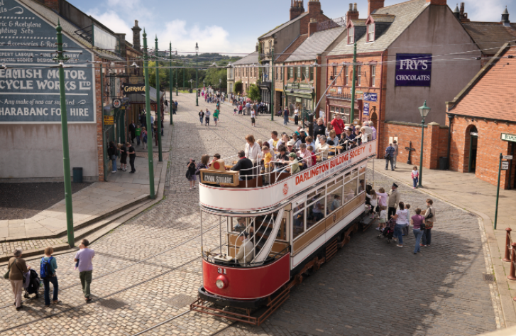 | PE  As sports people we want to know and remember how to play dodgeball and hockey  Knowledge  Rules of Dodgeball and Quicksticks hockey  Continue to hold the hockey stick correctly develop small sided games,  Dribbling , Passing , Stopping the ball, tackling and shooting.  Dodgeball - (Access coaching)Games, throwing and aiming. Games strategies, tournament participation, agility  Vocabulary pass, dribble, shoot, tackle, find space, teamwork, throw, catch, dodge  We want to practice how to (do)  Skills  Controlling the ball , developing speed and accuracy, pass, look for space, intercept  Working with a partner / group of 4 / small team to move the ball around.  Defending - blocking and tackling.  Throwing and catching skills  Aiming the ball, dodging the ball,  Play as a team  Compete in a competition (eg . hockey festival)  Additional : Bikeability some children signed up for cycling skills (full day)
PSHCE  As citizens of our community and the wider world we want to know and remember  Knowledge  To understand how exercise affects the body and know why the heart and lungs are important organs.  To know that the amount of calories, fat and sugar there is in our food can affect our health.  To know what a balanced diet is.  To know that all medicines are drugs but not all drugs are medicines.  To know that some drugs can be harmful to our bodies.  To know that there are things, places and people that can be harmful.  To know strategiesfor keeping ourselves safe.  Vocabulary  Balanced diet  Healthy Lifestyle  Exercise/ Fitness  Oxygen  Organs  Heart/Lungs  Strategies  Advice  Anxiety  We want to practice how to (do)  Skills  Make healthy choices  Set a fitness challenge  Measure risk and take sensible decisions  Develop strategies that look after both our physical and mental health. | RE  As citizens of our community and the wider world we want to know and remember  Knowledge-  When is Lent and why do Christians observe Lent.  Recap upon the Easter Story / Last Supper.  Palm Sunday - meaning and significance  Symbolism - Why do we have Easter eggs ?  Passover - why did Jesus go to Jerusalem , what is Passover ( what does it mean to Jews)  Skills- learn about reflect on and respect other religions  Christian communities around the world.  Links to other religions (Judaism)  Respond to sacred writings ( know the sources of Easter story in Bible)  Reflect upon right and wrong. Why did Roman leaders feel threatened by Jesus.  How did Jesus show forgiveness ( how does he respond to Judas ? ) | Design and Technology  Spring 1  Art focus this half term  Link to topic work with mention significant Victorian inventions / Visit to Beamish  Eg. Development of railways, electric light bulb ,  Morse code, telegram , telephone, hot water systems , ceramic toilet , photographs  What would you like to invent?
ICT  As digital citizens we want to know and remember:  Knowledge- Know how to….  Use a variety of softwares and apps to edit and enhance downloaded images of patterns found in nature.  Vocabulary:alter, attribute, copyright, digital content, edit, evaluate, export, hue, import, layer, lasoo, photo retouching, saturation , save, search, software , web browser.  We want to practice how to (do)  Skills  - Acquire, store and retrieve images from cameras, scanners or the Internet for a purpose.  - Create images using a range of techniques to develop a particular style.  - Compare and contrast different art software or web-based tools.  - Use a lasso tool to select specific areas of an image.  - Use effects in photo-manipulation software to edit, change or enhance an image.  - Independently download and save images or video onto a computer.  - Independently upload images or video for use in editing software.  - Be able to resize various elements in a graphics or paint package.  - Use effects in photo-manipulation software to edit, change or enhance an image.  - Combine a number of images using layering.  - Import music, stills or video into video editing software for a specific project.  - Arrange, trim and cut clips to create a short film that conveys meaning.  - Add simple titles, credits and special effects. | MFL - French  In French lessons, we will be taken beyond Whitley Bay and learn about the wider world. geography and culture of France. Knowledge:  To say age and ask others how old they are  To say where you live and ask others where they live  To say which country you live in and which language you speak  To say names of countries surrounding France  To understand and use numbers 13-20, to practise numbers 0-20  To understand and say the days of the week  To listen to the story of The Very Hungry Caterpillar in French  To describe the weather using simple phrases  To learn the alphabet in French  We want to practice how to Vocabulary: Quel age as-tu? J’ai ___ ans.  Il/elle a ___ans.  Ou habites-tu? J’habite a… J’habite en…  C’est quel pays? C’est  La France, L’Angleterre,la Belgique, le Luxembourg, l’Allemagne ,la Suisse, l’Italie  Il/elle s’appelle ___il/elle habite a___  Treize, quatorze, quinze, seize, dix-sept, dix-huit, dix-neuf, vingt  Les jours du semaine, lundi, mardi, mecredi, jeudi, vendredi, samedi, dimanche  C’est quel jour aujourd’hui? Demain, hier  Une chenille, affamee,un papillon, une feuille,un oeuf, faim, mal au ventre,une pomme, deux pores, trois prunes, quatre fraises, cinq oranges  Il fait beau, il fait mauvais, il fait chaud, il fait froid, il pleut, il fait du vent, il neige, il fait du soleil
Maths  As mathematicians in our community and the wider world we will learn about multiplication, division and money. We will use our mathematical skills to reason and solve problems.  Knowledge-  Four number operations  Names and properties of 2D and 3D shapes  How to identify a fraction as a part of a whole  Fractions of numbers  Place value up to 4 digits  Multiplication and Division facts  Skills - Rounding to the nearest 10  How to use different amounts of money  Multiplying and dividing 2 digit numbers by 1 digit numbers.  Problem solving and applying our skills  Vocabulary  Fractions  Numerator / Denominator  Shape names  Round up / round down  Compare multiplication and division statements. | Science- Electricity  As citizens of our community and the wider world we want to know and remember  Knowledge:  Identify common appliances that run on electricity (mains/battery).  Identify the sources used to create electricity e.g. non-renewable such as fossil fuel e.g. oil, gas, coal and renewable sources e.g. wind, hydro, solar, geothermal, nuclear.  Identify the differences between AC (mains) and DC (battery).  Identify dangers of using electricity.  Know whether or not a lamp will light in a simple series circuit based on whether or not the lamp is part of a complete loop with a battery.  Know that a switch opens and closes a circuit and associate this with whether or not a lamp lights in a simple series circuit.  Name some common conductors and insulators and associate metals with being good conductors.  Vocabulary:electricity, sources, fossil fuels, renewable, solar, hydro, geothermal, wind. Insulator, conductor, cells, battery, wire, crocodile clips, bulb.  We want to practice how to (do)  Skills  Construct a simple series electrical circuit, identifying and naming its basic parts, including cells, wires, bulbs, switches and buzzers.  Construct a circuit for a purpose and debug.  Know how to make bulbs brighter in a circuit and explain why?  Construct a circuit to test materials to see if they are conductors/insulators of electricity.  Construct a circuit that enables the testing of metals that can be used to connect across a gap in a circuit. | Literacy  As citizens of our community and the wider world we want to know and remember  Knowledge  To listen to Tom’s Midnight Garden and to understand character and plot of the story  Vocabulary- non-chronological report, fictional writing, headings, subheadings, Write a diary entry and a letter  We want to practice how to (do)  Skills: write diary entry, a letter, a non-chronological report,  Write in paragraphs, use generalisers and introductory paragraphs, write in the first person, include feelings, chatty language, create toolkits and wordbanks, sentence structure, adverbials, noun phrases, use punctuation correctly, make ambitious word choices  Vocabulary, introductory sentence, definition, paragraphs, diet, habitat, appearance, amazing fact, invent, create, imitate,Tom, grandfather clock, characters, setting, Dear diary,
We will involve our families in our learning by - Using the online platform of Seesaw and our school website. Regular communication and homework.
Yellow reading record books form part of the dialogue, conversations in person/phone call.

The strategies to support our most vulnerable learners are - T, TA and peer support Homework clubs (Blossom club) , targeted work in lessons, Support with uniform, book bags, visits, water bottles when needed. Contacting parents / carers in alternative ways to Seesaw.

