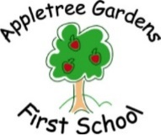 Pupil Premium Grant Allocation 15/16
Allocation of grant based on indicative figures from January 2014 Census
Number of pupils
Total number of pupils on roll- Nursery to Year 4 | 308 (FTE)
Total number of pupils eligible for PPG (inc Ever6) | 105
Additional PP allocation
Service/Adopted from care/Looked After Children | 5
Total | £127,000

Planned Expenditure
Staffing arrangements in place 2014/15 to continue including additional support staff in Reception; Interventions Lead ; Teaching Assistant; Increase one year group to 3 full time teachers- 3 classes.
Contribution to Y4 Outdoor Adventure week to Powburn for PP children
Increase in offer of Counselling Services for pupils
Further develop offer of social and emotional intervention for those children in need of additional support
Increase Educational Psychologist and EWO time allocated
Increase opportunities to enhance the curriculum for PP pupils eg. Visit to Commonwealth Ceremony, Westminster Abbey; Specialist support for STEM .

