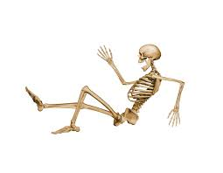
Topic: Fit for Life

Task 1: Can you find 5 interesting facts about the human body?
You can add pictures or labelled diagrams to impress your classmates.
Hand in Tuesday 19th September.

Task 2: Can you research and list sporting venues across the North-East?
Use Google to find out sports stadiums and arenas across a variety of sports. Find out which teams play there, capacity and even the team mascot!
Hand in Tuesday 26th September

Task 3: Design a healthy 3 course meal.
Imagine you are Jamie Oliver and you have been asked to serve a healthy meal for an Olympic athlete. Your meal must include a balance of all the main food groups and be appetizing.
Hand in Tuesday 3rd October

Task 4: Can you investigate what goes on food packaging?
Look at the different food packages in your kitchen cupboards? What information do they have on them? What are they made from? Do they have an eye-catching design? Draw and label your favourite food package and explain why.
Hand in Tuesday 10th October

Task 5: Can you create your own ‘Change 4 Life’ character in the style of Keith Haring?
Watch the adverts on T.V or online at www.nhs.uk/change4life and create a new character.
Hand in Tuesday 17th October

