Year Group:

History  As historians we want to know and remember  Knowledge  Who Roald Dahl was  Reasons why he is famous  Key dates and places associated with Roald Dahl  Vocabulary  Script, writing, Cardiff, famous, pilot, author, Norway.  We want to practice how to (do)  Skills  Sequence the famous books on a timeline  Sequence Roald Dahls life o a time line  Investigate the different books and characters that he created  Find out facts about Roald Dahl, including dates and places. | ICT  As computer scientists we want to know and remember  Knowledge  Understand what an algorithm is  Understand that programs execute by following precise instructions  Create and debug simple programs  Use logical reasoning to predict the behaviour of simple programs  Use technology purposefully to create, organise, store, manipulate and retrieve digital content.  Apply methods and features in an independent programming project.  Vocabulary  Algorithm, block, broadcast, command, control, debug, edit, execute, logic, program, repetition, save, script, selection, sequence, sprite  We want to practice how to (do)  Skills  Create and debug simple programs  Program the movement and appearance of an on-screen sprite  Use logical reasoning to predict the behaviour of simple programs.  Program sprites to create a short animation.  Program a number of sprites to move together.  Program scene changes in an animation  Design and program a maze game.  Use messaging to control sprites in a game. | Art and Design  As artists we want to know and remember  Knowledge  Create repeating patterns, varying the direction, pattern and colours.  To explore different textures-taking rubbings  To create a piece of frottage art.  Learn about the work of Max Ernst  To develop painting skills.  To study the work of Quentin Blake  To use sketching and watercolour techniques to create Roald Dahl story characters.  Vocabulary  pattern, repeat, colour, direction, create,  rubbing, texture  frottage, Max Ernst, texture, collage  Roller coaster,brush,paint  Quentin Blake, sketch, watercolour, illustrate  We want to practice how to (do)  Skills  Create repeating patterns using everyday objects.  Develop fine motor skills.  Identify different textures  Use colour to create different effects.  Develop and share art ideas, experiences and imagination  Know how to hold a paintbrush, load it with paint and use flowing strokes when painting.  Apply watercolour paints/ inks to create Quentin Blake style pictures.  Use sketchbooks to record thoughts and ideas and to experiment with materials.
Music  As musicians we want to know and remember  Knowledge  Find the pulse of music  Recognise Reggae music  Recognise and name instruments:keyboard, drums, bass, electric guitar, singers  Vocabulary  Keyboard, drums,bass, electric guitar, Reggae, pulse, rhythm, pitch, improvise, compose, perform, audience, melody, dynamics, tempo.  We want to practice how to (do)  Skills  Find the pulse  Clap rhythms  Create their own rhythms  Sing and dance in time and using actions  Play instrument parts  Compose and improvise, perform and share | Topic: Roald Dahl  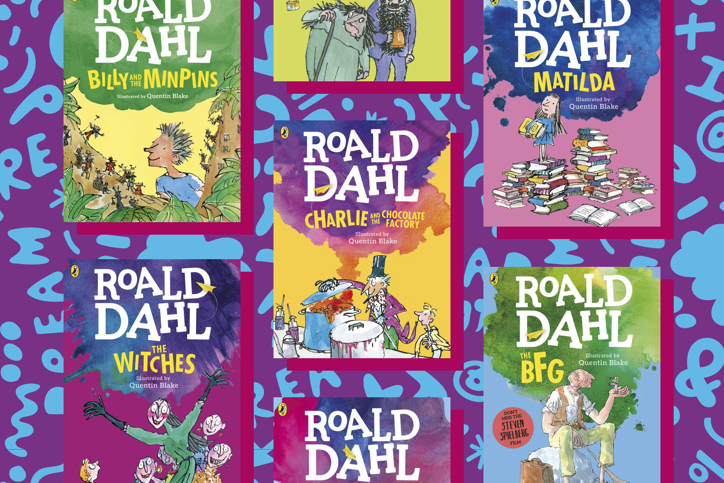 | PE  As sports people we want to know and remember  Knowledge  Skip through a rope  Coordinate arms and feet  Improve timing of movements  Improve balance stamina  Jump in a variety of different ways  Vocabulary  Jump, timing, balance, coordination, hop, run, partners, wide, consistent.  We want to practice how to (do)  Skills  Jump in different ways - double bounce. Step through, speed bounce, backwards bounce, partner bounce.  Big class rope - run, jump, out.
PSHCE  Knowledge  Healthy me  I know what I need to keep my body healthy  I am motivated to make healthy lifestyle  choices  I understand how medicines work in my body  and how important it is to use them safely.  To feel positive about caring for my body and  keeping it healthy  I can sort foods into the correct food groups  and know which foods my body needs every  day to keep me healthy.  Vocabulary  Physical health, mental health, food groups, energy, medicine, protein, carbohydrates, fats, sugars, healthy, unhealthy, snacks, treats, hygiene, sleep.  Skills  I can make some healthy snacks  and explain why they are good for  me. I can sort foods into the correct group. I can explain what happens if I have too much of a certain food. I can discuss ways to keep healthy | RE  Why is the Bible special to Christians?  How do Christians celebrate Easter?  Knowledge  New and Old Testament stories  Noah’s Ark  Daniel and the Lion  Moses- links to Judaism  David and Goliath  Jonah and the Whale  St Cuthbert local faith communities  Vocabulary  We want to practice how to (do)  Skills | Design and Technology  Vehicles  Knowledge  To investigate a variety of vehicles and their uses and features.  To investigate wheels, axles and chassis.  To be able to investigate ways of creating and  decorating the body of a vehicle.  To be able to design a vehicle.  To be able to make a vehicle based on a design.  Vocabulary  Vehicle, purpose, features, wheels, axis, chassis, design, turn, body, improve, evaluate, carry, drive.  We want to practice how to (do)  Skills  Analyse vehicles and their uses, and what features they have to achieve this.  Investigate how wheels, axis and chassis work in a vehicle.  Cut, design, measure, make.  Evaluate what went well and what could be improved next time.
Maths  Knowledge  Fractions  Reading scales  Partitioning numbers into tens and ones  +and - two digit numbers  X and ÷ counting in 2s, 5s,10s and 3s  Find different combinations of coins that equal the same amounts of money  Vocabulary  whole. part, equal part, half, quarter, three quarters, equivalent  scale, value, weight, length, liquid, cm,m, g,kg, ml,l  division, divide, share, share equally,  array, row, column, double, halve  partition, recombine, hundreds  coins, value, same  Skills  To develop fluency and the ability to reason mathematically to solve problems. Pupils will reason about what they already know to solve problems and improve fluency. Children will have be able to make mathematical connections. | Science  Knowledge  Animal young and comparing them to their adults.  How animals change as they grow up.  Introduced to the life cycles of several varied common animals, including humans.  How humans change as they grow older.  The basic needs of animals for survival.  Vocabulary  Offspring, young, growth, survival, mammals, reptiles, birds, fish, amphibians, characteristics, live young, eggs, toddlers, babies, teenagers, changes, adults, food, water, air.  Skills  Children can sort and classify objects (animals). Children can describe the main stages of at least two different animal life cycles. Children can identify and match several animal offspring and their adult forms.  Children can name the three basic needs of all animals to survive. Children can identify several ways that humans grow and develop through each life cycle stage. | Literacy  Knowledge  TFW text - the Enormous Crocodile.  A flawed character focus.  The change of a character, looking at the behaviours and attitudes of the character. What tricks and the purpose of these. How the character can be stopped, and why. Chn to create their own flawed character and design tricks and how to foil them.  Speaking and Listening Reading  Daily phonics -differentiated groups  Guided Reading  Opportunities to read in foundation subjects.  Home School reading  Reading for Pleasure  Books to share  Designated class story time  Vocabulary  Opening, build up, dilemma, resolution, ending, setting, adjectives, speech, verbs, cunning, secret, plans, tricks, camouflage, disguise, attitudes, behaviours.  Skills  Create logical and clear plans, sustain their writing, use speech and add detail to their work. Use their phonetic knowledge and resources available to spell CEW accurately. To have clear and legible handwriting. Begin to self check and peer mark work.
We will involve our families in our learning by:
Literacy Drop in
Easter Reading Challenge
Parent Teacher Consultations.
The strategies to support our most vulnerable learners are

