APPLETREE GARDENS FIRST SCHOOL
Appletree Gardens, Whitley Bay, Tyne & Wear, NE25 8XS
Tel: (0191) 252 3546 Fax: (0191) 252 9388
Email: info@appletreegfs.org.uk
www.appletreegardens.org.uk
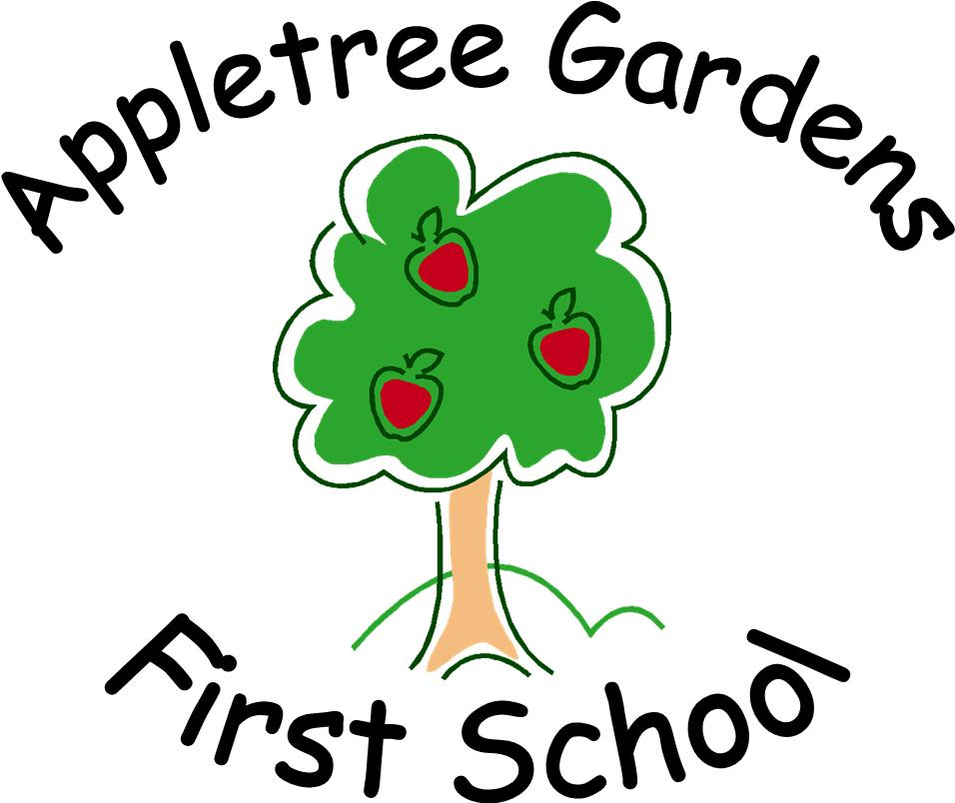

Enjoy, Achieve, Succeed

Headteacher : Mrs Wilkinson BA PGCE NPQH
08/01/2021
Dear Parents and Carers,
Happy New Year!
It certainly isn’t the start we were hoping for. Firstly, I’d like to say a big thank you to our school community for your messages of support and kindness as we once again re-organise school. We will do everything we can to support our families at this difficult time.
We are providing children with daily age specific learning via our online platform Seesaw. This provides a suggested timetable for the day and links to learning. Our staff have also been adding some videos so that the children have regular contact with teachers. Staff will respond on Seesaw but if you post at night this may be the following day as our staff have preparation, planning and often their own families to support.
Our school network does need some upgrading and we are looking at this in order to provide some live sessions. Please be assured that we are here to help in any way we can.
Any new requests for school provision should be sent to the school office.
Families who receive benefits related free school meals can collect a food hamper from school each week. Catering Services advise the hampers will be dropped off at school every Thursday. We will let those parents/carers know when they are ready to be collected.
Stay in touch
Please stay in touch regularly with us. We will get through these difficult times by supporting one another.
Kind regards
Jayne Wilkinson



