Year Group:3

History  As historians we want to know and remember  Knowledge  Know how people of the Stone Age lived during the 3 main time periods- Paleolithic, Mesolithic and Neolithic e.g. nomadic tribes that moved due to seasons in search for food through to settlements and farmers in the Neolithic period.  Know how the Stone Age people hunted, used weapons and the importance of flint.  Know how foods eaten in each Stone Age period changed.  Identify changes to Stone Age houses from those like teepees made from animal furs to more permanent structures built from wood and stone and how these changes were linked to the invention of farming.  Vocabulary hunter, gatherer, nomadic, settlement, prehistoric, Paleolithic, Mesolithic, Neolithic, archaeologist, Skara Brae, weapons, flint. Decade , century etc.  We want to practice how to (do)  Skills  Develop knowledge of chronology  Make links between different historical periods  Use a range of source materials to ….  Remember key facts  Investigate a period before books / records began. Prehistoric] | Geography  As geographers we want to know and remember  Knowledge: Know and identify the 4 countries and capital cities that make up the UK.  Identify destinations of recent visits on a map of the UK.  Identify landmarks visited.  Identify seas/oceans surrounding the UK.  Explain how land mass has changed since the Stone Age (rising sea levels) separation of UK from Europe and impact this had on movement of nomadic tribes.  Identify settlements such as Skara Brae from the Stone Age and understand the reasons why they were chosen e.g. locality, positions to aid hunting/food supplies.  Vocabulary: United Kingdom, England, Scotland, Wales Northern Ireland, destination, coastline, countryside, seas, landmarks.  We want to practice how to (do)  Skills  Use an atlas , globe , google earth  Identify settlements and why people chose certain place. | Art and Design  As artists we will be introduced to cave art and reflect upon the purpose of the drawings before working on developing their sense of proportion in drawing  Knowledge and skills  To learn how prehistoric man made art and to reflect this style in their work Develop techniques, including control and their use of materials, with creativity, experimentation and an increasing awareness of different kinds of art, craft and design To scale up drawings and sketches in a different medium To apply and blend charcoal to create tone and texture To understand that people from the Stone Age didn’t have access to paints, so they had to use natural objects to create marks and shapes, e.g. crushed berries, burnt wood, plants, animal fats mixed with natural pigments. To experiment with the pigments in natural products to make different colours To develop painting skills and to mix paint to create a range of natural colours To experiment with techniques to create different textures and add fine detail using smaller brushes To collaborate in small or large groups to create a joint piece of artwork Vocabulary - draw, paint, charcoal, pigment, paint, natural, composition, colour mixing, cave painting, collaborative, cave wall, positive image, negative image
Music  As musicians we want to know and remember  Knowledge  How to play an instrument - Ukulele  Vocabulary  We want to practice how to (do)  Skills  Pitch  Basic notation  Dynamics (loud and soft )  Appraising and responding to music  Different styles of music  Classical, jazz, pop, blues etc. | Topic:  Question driver:  Would you rather live in the stone age or the present day ?  Project\ purpose: Build up to a stone age day with firepit etc.  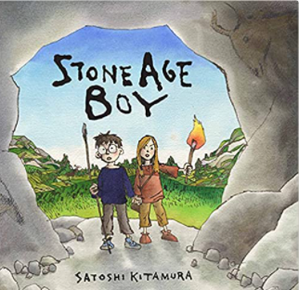 | PE  As sports people we want to know and remember  Knowledge  - To choose and apply skills to make up games  - To describe their game to someone else  - To include different elements within a game (throwing, catching, teamwork)  - Tri -golf Unit  Vocabulary  Partner, teamwork , points, scoring ,move , control, accuracy  We want to practice how to (do)  Skills  Pass and receive a ball, bean bag, coit in small group games.  Develop position and mvt techniques  Work out basic point scoring systems
PSHCE  As citizens of our community and the wider world we want to know and remember  Knowledge  Setting personal goals  Self identity  Being positive  Rights and responsibilities  Rewards and Consequences  Vocabulary  Positivity, Reward, Consequence, Citizen, Class charter, Zones of regulation, Jigsaw  We want to practice how to (do)  Skills  How to make responsible choices  How to see things from an others perspective  How to develop out self worth and confidence  How to regulate our feelings and know that our actions have an impact on others | RE  As citizens of our community and the wider world we want to know and remember  Knowledge  As part of our developing understanding of different religions and cultures we will find out  Where and how do Hindus worship  What are their main festivals and customs  Some of the Hindu stories and teachings  Vocabulary  Divali, Mandir, Brahman, deities , Rama and Sita,  Puja, Ramayana, Pilgrimage  We want to practice how to (do)  Skills  Understand the importance of rituals, objects , symbols and food.  Develop an understanding of how religion has an impact on our daily lives. | Design and Technology  Focus in Aut 2  Some DT related to Topic  As designers\ engineers\ carpenters etc.. we want to know and remember  Knowledge  How to make a stone age tool  How to light a fire  Vocabulary  Flint , Bind , Stone , Wood  Soft wood  We want to practice how to (do)  Skills  Pick materials (sharp stones)  Hammer into soft wood  Bind string round a stone o fix it
ICT  As digital citizens we will using devices responsibly and safely.  Knowledge and skills:  We want to:  Recognise the ways in which digital devices can be distracting and dentify how they feel when others are distracted by their devices.  Identify ideal device-free moments for themselves and others. Understand that they should never give out private information online. Learn that the information they share online leaves a digital footprint or "trail" Explore what information is OK to be shared online Compare and contrast how they are connected to different people and places, in person and on the internet Demonstrate an understanding of how people can connect on the internet Understand what online meanness can look like and how it can make people feel Identify ways to respond to mean words online, using S-T-O-P Vocabulary: online, internet, private, privacy, safety. Stay safe, share, don’t share, personal, digital footprint, community, world, responsibly, respectful, full name, address, photos, school name, birthdate, passwords, perChidistraction | MFL - French  In French lessons, we will be taken beyond Whitley Bay and learn about the wider world. geography and culture of France. Knowledge:  To talk about France and its geographical features and culture.  To say hello and goodbye, answer the register To understand simple commands To say their name and ask others their name using ‘et toi?’ To say what somebody else's name is.  We want to practice how to greet each other, introduce ourselves and ask and say how we are.  Vocabulary: La France, les alpes, les pyrenees, la loire,l’ocean atlantique, la mediterranee, la manche, Paris, Calais, l’eurostar, Douvres, Bonjour, salut au revoir, je m’appelle, comment t’appeles tu? Il s’appelle, Elle s’appelle, Oui/non, Ca va? Ca va bien, merci. Et toi? Ca va mal.Comme ci, comme ca | 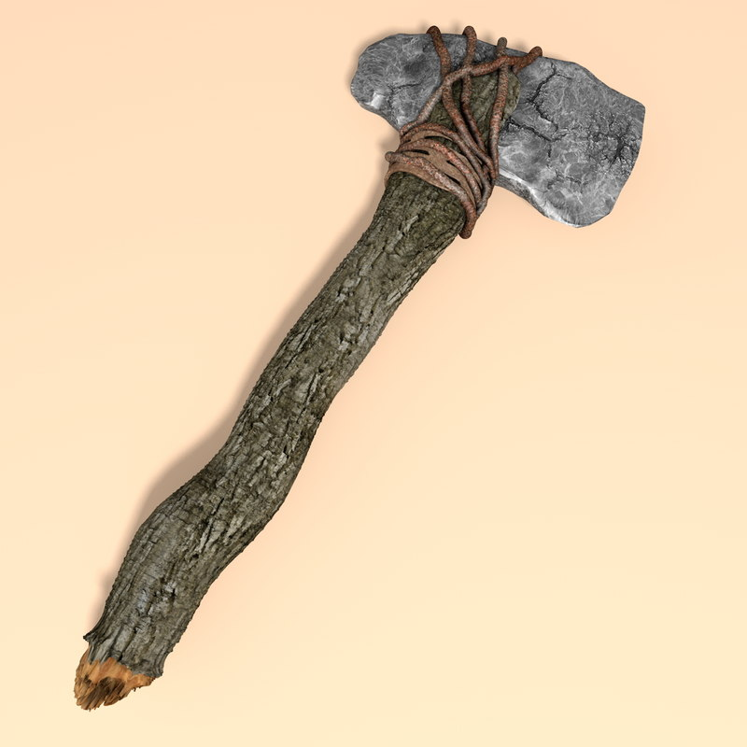  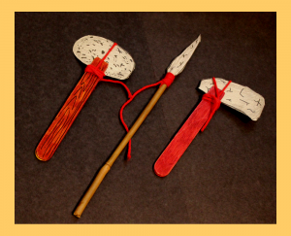
Maths  As mathematicians in our community and the wider world we will learn about numbers and the value of each digit. We will learn that a 3-digit number is made up of some 100s, 10s and 1s and will be able to represent this in many ways (for example, on a place value grid with counters or in a part-whole model). We will extend the number line to 1,000 and know where different numbers lie. We will compare and order 3-digit numbers as well as count in 50s When calculating we will add and subtract 1s and 10s to/from 3-digit numbers, add and subtract 3-digit and 2-digit numbers, We will learn when to exchange 1s, 10s and 100s. We will add and subtract using mental and written methods . We will practise mental recall of multiplication facts for 2, 3, 5 and 10 times tables and begin to learn the division facts. Vocabulary place value, position, digit, thousands, hundreds, tens, ones, greater than, less than, addition, subtraction, plus, take away, minus, total, mental method, number bonds, written method, exchange, column method, inverse, times, multiplied by, lots of, groups of | Science  As citizens of our community and the wider world we want to know and remember  Knowledge  How rocks are formed  What the different types of rocks are  How rocks are used  Vocabulary: rocks, soils, fossils, Igneous, Sedimentary, Metamorphic.  We want to practice how to (do)  Skills  Identify, sort and classify rocks, soils and fossils.  Observe and identify the properties of different rocks and soils e.g. permeable, impermeable, soft/hard, buoyant.  Work scientifically to plan and carry out investigations into the properties of rocks and soils. | Literacy  As citizens of our community and the wider world we want to know and remember  Knowledge  We will look at the features of an adventure story and the features of instructional writing.  We will read “Stone Age Boy” and learn lots of information about this period in history in addition to studying the style of this non-fiction book.  Vocabulary;  Parts of speech. Verb, adjective, noun, imperative verbs.  Punctuation , commas and speech ,marks  Develop all aspects of our vocabulary through description of a setting and laying a trap.  We want to practice how to (do)  Skills  Write an adventure story with a beginning, build up, problem, resolution and ending.  Write instructions using features such as subheadings, time connectives and imperative verbs.  To edit out work and use punctuation effectively.  To write in paragraphs or sections as appropriate to the genre we are writing in.
We will involve our families in our learning by - Using the online platform of Seesaw and our school website. Regular communication and homework.
Yellow reading record books form part of the dialogue, conversations in person/phone call.

The strategies to support our most vulnerable learners are - T, TA and peer support Homework clubs (Blossom club) , targeted work in lessons, Support with uniform, book bags, visits, water bottles when needed. Contacting parents / carers in alternative ways to Seesaw.

