Year Group:3 Spring 1 Teeth & Healthy Eating

History  Geography Focus Spring 1 | Teeth and Healthy Eating | Art and Design  DT focus Spring 1
Music  As musicians we want to know and remember  Knowledge  Vocabulary - chord names D G C, quaver, crotchet, semi breve, minum, treble clef, piano forte  We want to practice how to (do)  Skills  Play tuned instruments (ukulele and glockenspiel), and follow notation.  Learn new chords, notes and perform songs | Geography  As geographers we want to know and remember…  Knowledge: Land Use  To be able to :-  identify important landmarks in my locality  talk about the purpose of a sketch map  talk about the features of a sketch map  use a key on a map  understand why we use symbols on a map  know the difference between rural and urban land use  Vocabulary:  sketch map, aerial view, street map  feature, landmark, key, symbol, urban, rural  We want to practice how to (do)  Skills  draw a simple sketch map showing landmarks and features  read a map using a key and symbols  include our own symbols and key on a map  identify which features/landmarks are similar or different in rural and urban landscapes. | PE  As sports people we want to know and remember  Knowledge Quick sticks Hockey,  How to hold the hockey stick, small sided games  Dribbling , Passing , Stopping the ball.  Dodgeball - (Access coaching)Games, throwing and aiming. Games strategies, tournament participation, agility  Vocabulary  We want to practice how to (do)  Skills  Controlling the ball , developing speed and accuracy.  Working with a partner / group of 4 / small team to move the ball around.  Defending - blocking and tackling.
PSHCE  As citizens of our community and the wider world we want to know and remember  Knowledge Healthy Me  To understand how exercise affects the body and know why the heart and lungs are such important organs.  Vocabulary  Oxygen ,heartbeat, lungs, heart, fitness  We want to practice how to (do)  Skills engage in a variety of exercises/activities e.g running, jumping, skipping, dancing, cycling,dodgeball,playing,football,netball,basketball,trampolining,gym,acro, etc. Include any exercise/ activity that makes you breathe faster.  Set a fitness challenge. Challenge the children to do some exercise everyday which makes them breathe faster as this will help their heart and lungs stay fit and strong.  Knowledge Dreams and Goals  To identify a dream/ambition  To work in a group to achieve a goal  To know that you need specific skills to achieve a goal or dream  Vocabulary  Dreams, goals, ambitions, future, aspiration, teamwork, co-operation, career, skill  We want to practice how to (do)  Skills  Calm our bodies and minds through guided breathing  Open our minds /Share our dreams/ goals with our peers (Circle time)  Listen to each other, respect each others views and value all ideas. Take turns, assign group roles, work as a team to produce an end result, evaluate and improve a design  Think about what skills are needed for certain careers | RE  As citizens of our community and the wider world we want to know and remember  Knowledge- How do Hindus’s Worship  Vocabulary - Belonging, Symbolism , Mandir, Aum , Vedas, Puja , Brahman , shoe rack, shrine, charanamrita, aarti plate , prasada  Skills- learn about reflect on and respect other religions  Theme of Belonging - what does it mean to belong  Religious symbolism and customs  How Hindus pray at home and in the Mandir  Mandir design / symbolism / differences round the world.  Reflection and understanding  Topic:  Question driver:  How do we keep our teeth healthy ?  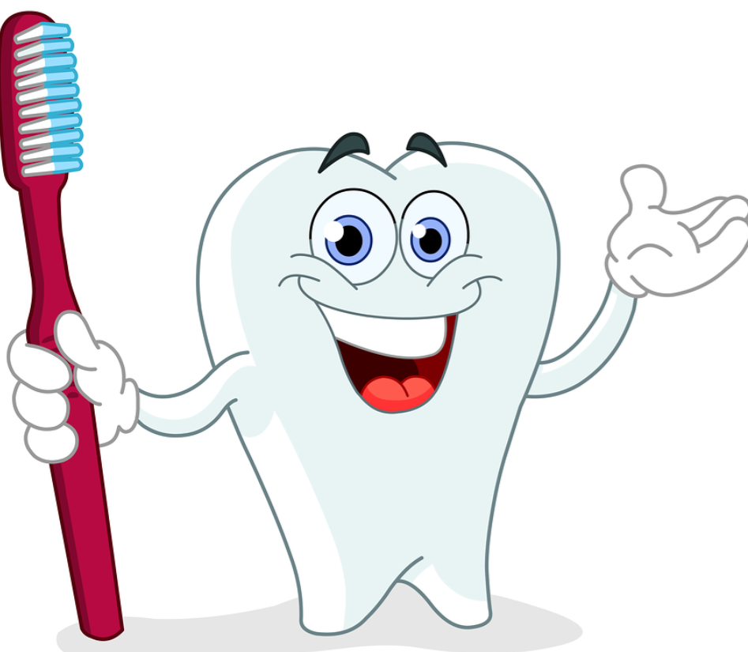 | Design and Technology Sandwiches  As designers\ engineers\ carpenters etc.. we want to know and remember  Knowledge- know that food can be divided into different groups, name different food groups and describe their purpose, understand people have different preferences, know there are a variety of sandwiches, taste and describe different foods, know that combining different foods affects the taste and texture of sandwiches, choose a purpose for a sandwich, describe each step in the process of making their sandwich,design a healthy sandwich, know how to work safely and appropriately with food, follow their designs to create a sandwich, present their sandwich in a appealing way, evaluate their work fairly and constructively, Suggest improvements to their design, incorporate new design features based on their experience of the product.  We want to practice how to (do)  Skills: work hygienically, peel, chop, slice, grate, spread, discover new tastes and use knives and kitchen utensils safely
ICT Databases  As digital citizens we want to know and remember:  Knowledge and skills: Understand and explain what a database is; Identify records and fields of a database; Identify advantages and disadvantages of using databases; Select appropriate data to add to a database; Contribute to a class database; Search and sort a database; Search a database to find information; Make a chart from information in a database; Interpret a chart and report findings; Compare different methods of collecting data; Understand and explain open and closed questioning; Create and use an online survey; Present information from a database.  We want to:  Build and search a database,  Turn data into graphs  Interpret data from graphs and report findings  Compare information  Compare different methods of collecting data  Understand and explain the difference between open and closed questioning  Create and use an online questionnaire for data collection  Vocabulary - cloud storage, data,database, edit, evaluation, export, field, import, rank, record, save, search, sort | MFL - French  In French lessons, we will be taken beyond Whitley Bay and learn about the wider world. geography and culture of France. Knowledge:  - Understand and use names for classroom objects and furniture  Understand le, la les, mon, ma, mes  - To say age and ask others how old they are  - To say where you live and ask others where they live  - To say which country you live in and which language you speak  - To say names of countries surrounding France  - To understand and use numbers 13-20, to practise numbers 0-20  Vocabulary: Qu’est-ce que c’est? Qu’est-ce qu’il y a dans ma trousse/mon sac a dos?  Il y a un/une… un crayon, un stylo, une gomme, un taille-crayon, une regle, une trousse, une calculatrice, une calculette, un livre, un cahier, un baton du colle, des feutres, des ciseaux, un compass  Tu as…? Oui, j’ai… Non, je n’ai pas de..  Voila!  Dans la salle de classe il y a…  La porte, la fenetre, le tableau blanc, la table, le tapis, la poubelle, la chaise, l’ordinateur, le professeur, les eleves  How old are you -Quel age as tu?  Where do you live? Ou habites-tu?  Which country?  Quel langue parles-tu?  Can you count to 20 in french? Can you match number names to written names?
Maths  As mathematicians in our community and the wider world we will learn about multiplication, division and money..  Knowledge- 2 and 3 digit Addition / Subtraction with exchange of tens and ones .  Assessment of times tables 2,3,4,5 and 8  Developing speed  Money (value of notes and coins) Addition / subtraction of money  Multiplication and division 8 x table focus  ICT - Using My Maths to support curriculum  Skills - Checking , estimating , connections in number bonds (10s, 20s, 100) ,  Multiplication patterns, breaking down problems in problem solving activities.  Applying money to real life situations.  Vocabulary  Exchange , estimate , digits , multiple , pounds, pence, convert, total, difference , change  Multiply, divide, groups, array | Science-  As citizens of our community and the wider world we want to know and remember  Knowledge:  Know that we have 2 sets of teeth-(milk/deciduous and adult/permanent).  Remember we have upto 32 permanent adult teeth.  Know that teeth are made up of enamel, dentine, pulp, nerves and a root which holds the tooth securely into our jaw/gums.  Know that as humans we have 4 different types of teeth each with a different job-incisors for biting, canines for tearing, pre-molars chewing and molars for chewing and grinding.  Understand that animals have different teeth depending on their diet and whether they are herbivores, carnivores or omnivores.  Know ways in which we can look after our teeth e.g. brush with fluoride toothpaste, visit dentist, eat and drink foods that do not cause harm to our teeth.  Recall foods and drinks that may harm our teeth and explain the impact acids/plaque have on the enamel of our teeth.  Vocabulary:teeth- incisor, canine, pre-molar, molar, milk/deciduous, adult/permanent, enamel, dentine, pulp, nerve, root, gum, jaw bone, decay, plaque, biting, chewing, grinding, herbivore, carnivore, omnivore,  We want to practice how to (do)  Skills  Correctly brush our teeth.  Look after our teeth correctly throughout our lifetime.  Be able to choose foods and drinks that do not harm our teeth. | Literacy  As citizens of our community and the wider world we want to know and remember  Knowledge -read as a reader, be inspired by and learn new stories, learn how to plan and write our own stories following a story mountain structure and Talk for Writing. Write a non-chronolgical report based on Healthy Eating. Join handwriting using Nelson  Vocabulary non-chronological report, fictional writing, headings, subheadings,  We want to practice how to (do)  Skills: descriptive sentences and paragraphs, write a story with characters and a plot, write a report, imitate, plan and write a story based on a TFW text, write a non-chronological report  Vocabulary: setting, characters, plot, beginning, build-up, dilemma, problem, resolution, ending, noun phrases, adjectives, commas in lists, a or an, direct speech, inverted commas, capital letters, full stops
We will involve our families in our learning by - Using the online platform of Seesaw and our school website. Regular communication and homework.
Yellow reading record books form part of the dialogue, conversations in person/phone call.

The strategies to support our most vulnerable learners are - T, TA and peer support Homework clubs (Blossom club) , targeted work in lessons, Support with uniform, book bags, visits, water bottles when needed. Contacting parents / carers in alternative ways to Seesaw.

