2016-2017 Vision
The last three years sport and Physical Education at Appletree has continued to grow and we have built upon the success year on year. We have continued to commit time and resources to PE and we are proud of what we have achieved so far.
New targets and aims have been established for this year:

- To continue to achieve Sainsbury’s School Games Gold award.
- To develop the outdoor playground to make it interactive for play and lunch times.
- To establish the ‘mile a day’ routine for children
- To involve and encourage the less active children.
- To give teachers the opportunity to be involved in CPD.
- To attend festivals and maintain the progress in the School Games Medal Table

**Summer term update**
WOW! We have achieved so much, and we will keep pushing until the end of the year!
We have made some big changes and additions to PE and sport at Appletree and we are thrilled with the results.

Looking smart!
We invested money into 11 brand new full competition strips PLUS training jackets. We got a chance to wear these first of all in the recent year 4 quicksticks tournament. The children we so proud to wear the new jackets, and members of the public commented on how smart they were, as we made our way down to the venue.
We teamed up with ‘Personalised and Printed’ and together came up with the new design.
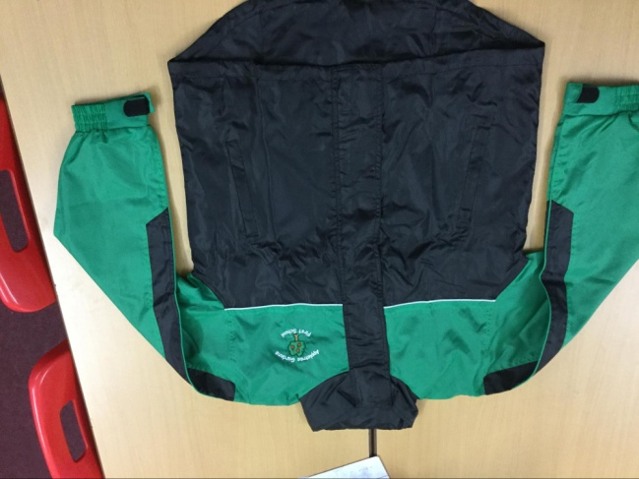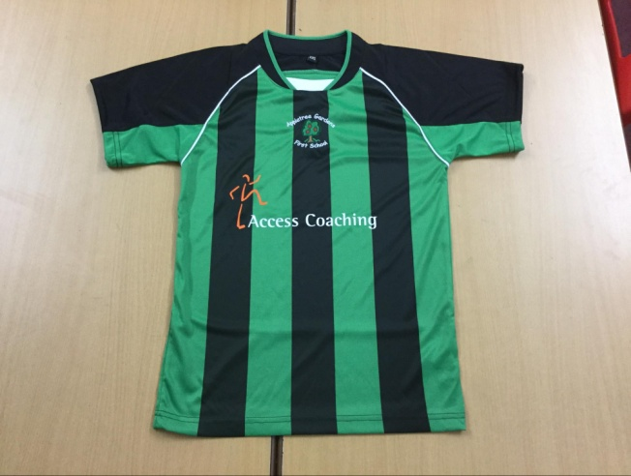

New Year Family Fitness!
January is always a tough month to get motivated, and many a New Year Resolution doesn’t last long. What better way to jump start your fitness drive than to exercise with your child! We offered 30 FREE places for adults and their child to join us in fun fitness!
A local dance and sports teacher was brought in to bring some fun to an after school activity. Everyone who joined in loved it and asked if we could run it again.....! We currently have plans to do so in the summer term. A mixture of Zumba, circuits, boot camp and team games we all included over the sessions.

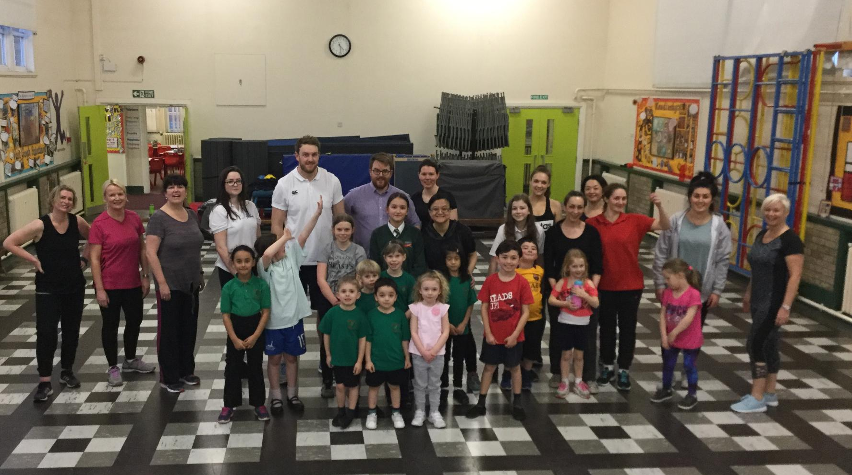
Impact
- Increased levels of enjoyment by those who participated.
- A chance to try new drills/physical activities.
- Strengthened pupil/parent/school relationships.
- The chance to start a healthier lifestyle/kick start physical activity.

Lunch time get active!!!

We wanted to start the New Year with a bang so offered FREE places to all the school over lunch times for the entire spring term. We really want the children to be active and try a new sport, as well as having fun!
Monday – year 1 dodgeball
Tuesday – Year 2 dodgeball
Wednesday – reception football
Thursday – KS2 dodgeball

The sessions are carried out by Access coaching, a local and fully qualified coaching team, who tailor the sessions to the needs of the children.
All children who wanted to participate were welcome.

Impact
- Increased numbers of children being active at lunch time.
- Promoting sportsmanship and teamwork amongst peers.
- KS1 was attended by a massive 93% of children
- KS2 was attended by a very positive 68% of children.

Playground revamp!
We want our children to be proud of their surroundings and have made some big improvements all across the yard. The PE and playground team helped to choose the new markings as well as working with teachers on the design features.

KS1 football area
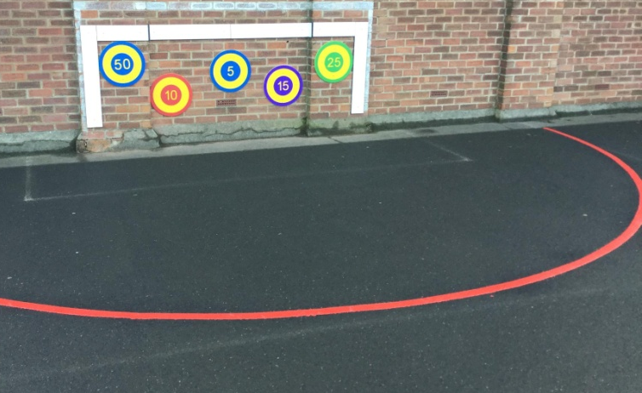

A giant ‘snakes and ladders’ in very colourful squares have a real impact on the yard along with the huge twister spots!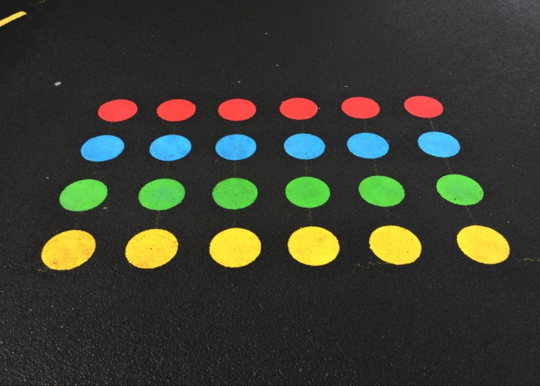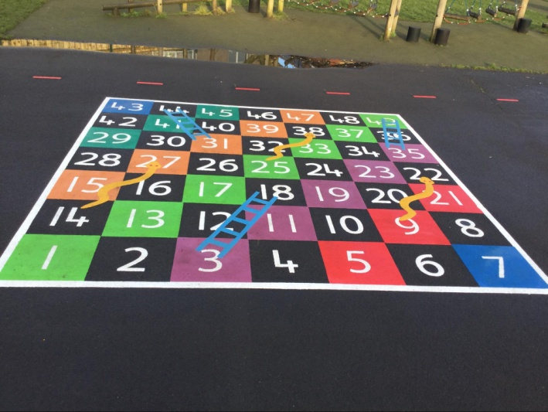

A massive 30m x 20m training grid gives 3 or 6 designated areas for use during both free time and PE lessons.
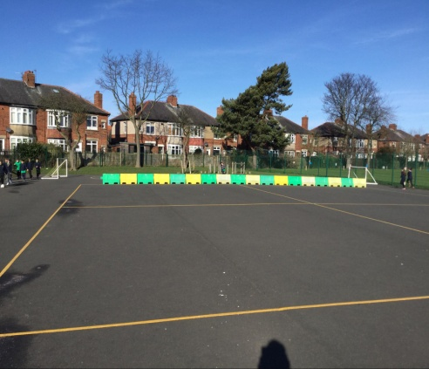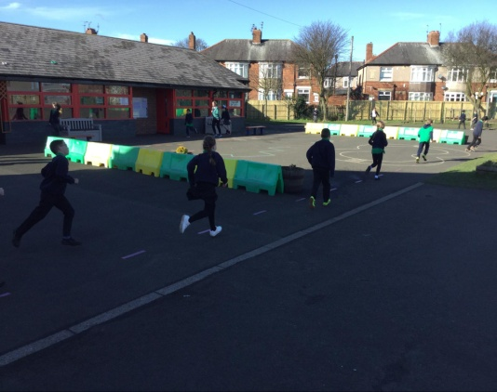

EYFS line-up spaces

Impact
- Visually the yard now carries a big impact of first seeing it.
- KS1 football area - we wanted to give the chn more ideas and fresh enthusiasm for their games.
- The barriers give more structure and designated areas for children to play safely.
- Staff have reported that pre determined grids and areas would make teaching and the logistics of PE lessons easier, and less time would be spent on marking out areas with cones.
- Snakes and ladders and twister spots - a welcome addition for the children to use and increased enjoyment.
- Reception Appletree line up spots - chn enjoy their new markings and make links with the school name and their class number.
- The PE team have taken a very active part in the design and implementation of the new design.

A mile a day
After months of planning and careful consideration, we finally found a design and pathway to create our very own Mile a day challenge.
The research suggests that running 1 mile per day helps to increase good behaviour, increases levels of concentration, improves fitness and in some studies, reports had shown an increase in academic abilities.
Here at Appletree we have marked out a 230metre coloured track. 7 full laps would equal running 1 mile.
The idea is that the children run the mile in their uniform (swapping to appropriate shoes in some cases) and heading out for their run. It is hoped that after the initial excitement and novelty, that long term, this become habit and part of their daily routine.
Year 4 have pencilled times within their timetable and are currently trailing this.
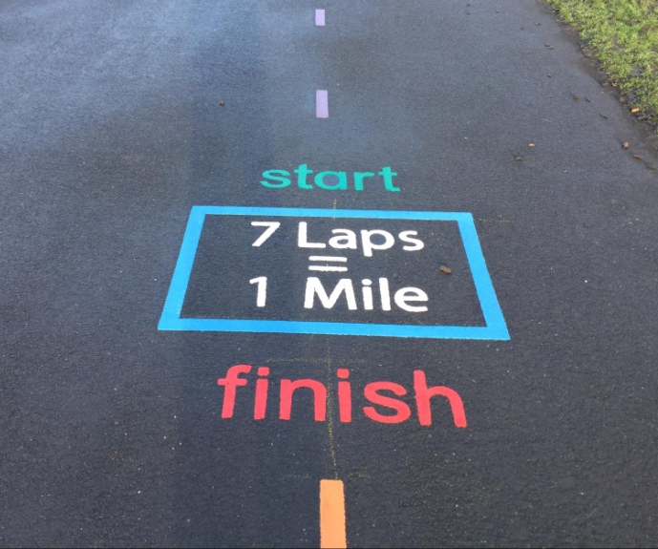

Impact
- Year 4 staff have noticed an increase in concentration amongst children.
- Visibly fitter children – compared to the first miles run, they are now comfortably able to run without stopping.
- Increased motivation to run from chn (introduction of incentives)
- Year 4 have realised that it is possible for the scheme to work – regards to timetabling.
- Other year groups are currently running their version of the mile a day – eg 10mins, 4 laps and will review at the end of the year.

CPD available this year for staff

Over the year staff have had the opportunity to suggest areas in which they would like CPD. The idea behind CPD is that the staff are able to up-skill and therefore will lead to new and improved PE lessons, and different sessions for the children. The staff undertook a questionnaire at the beginning of the year and this highlighted areas that the staff would like to work on.

Nursery have had 7week Games sessions with both am and pm nursery groups.
Year 1 had ball skills and games CPD, using the markings on the yard for setting up/logistics of arrangements.
Year 2 split their sessions between cricket and hockey.
Yea 3 and 4 have continued to receive a variety of CPD in areas such as handball, fencing, cricket, dodgeball.

Impact
- More confident staff
- Increased staff knowledge
- More exciting opportunities and sessions for chn.
- Y3/4 – the sessions lead to a level 2 competition therefore more chn involved in competition, representing AGFS

