Year Group 2:

 | Autumn 1  Grace Darling | Autumn 2  Endangered Animals | Spring 1  Japan | Spring 2  Roald Dahl | Summer 1  Great Fire of London | Summer 2  Pirates  Land Ahoy!
Investigation | Who is Grace  Darling and what is she famous for? | How can we look after our planet? | Where would you rather live? | Who will win the Golden Ticket? | What started the fire? | Yo Ho Ho - Is a pirate’s life for me?
Project end purpose | Seesaw Presentation assembly to parents | Make links with the WWF | Leaflet  comparing and contrasting England/Japan | Class to publish their own ‘Enormous Crocodile’ chapter book. | Burning houses made in DT | Pirate Party  Completing pirate licence
Visits and visitors | Grace Darling Museum  RNLI | Kirkley Hall Zoo  Animal Antics/Crazy Creatures  Blue Reef | Little Foodies - Japanese food | Easter church visit  St Peters | Churchill Playing field | Captain Raggybeard  Rising Sun Country Park
Maths | Number – number and place value 1 Numbers to 100 10  Number – addition and subtraction 2 Addition and subtraction  Number – addition and subtraction 3 Addition and subtraction  Measurement 4 Money  Number – multiplication and division 5 Multiplication and division |  | Number – multiplication and division  Statistics - Statistics  Measurement - Length and height  Geometry – properties of shape  Number – fractions 10 Fractions |  | Geometry – position and direction  Number – addition and subtraction  Problem solving - using efficient methods  Measurement - Time  Measurement - Weight, volume and temperature
Literacy links and genres | Lighthouse Keeper’s Lunch  (3 weeks)  BEATING THE BADDIE  Focus  Characterisation and dialogue  Writing Purpose  To write their own beating the baddie story.  Grace Darling Museum  (2 weeks)  RECOUNT  Focus  Beginning, Middle and Ending  Writing Purpose  To write a recount of Bamburgh Grace Darling Museum visit  SPINE POEM  (1 week)  POETRY  Focus  Spine poem  Writing Purpose  To create a descriptive spine poem to depict a stormy sea | Meerkat Mail  (3 weeks)  JOURNEY / MEETING TALE  Focus  Setting  Writing Purpose  Recount a new visit for Sunny.  Orangutans  (3 weeks)  INFORMATION TEXT  Focus  Linking facts  Writing Purpose  Writing to inform- information text about a made up animal. | Japanese Folktale  (3 weeks)  FINDING TALE  Focus  Writing Purpose  The Magic Paintbrush or Japanese folk tale  Creating Plots and Paragraphs  Japanese Culture and craft instructions  (2 weeks)  INSTRUCTIONS  Focus  Using commands and sequencing  Writing Purpose  Write a set of instructions to make sushi.  IF I HAD WINGS  By Pie Corbett  (2 weeks)  POETRY  Focus  Repetitive structure  Writing Purpose  Creating an If I Lived In Japan poem. | The Enormous Crocodile  (3 weeks)  CHARACTER FLAW  Focus  Characterisation  Writing Purpose  To write their own clever trick.  The Twits  (2 weeks)  EXPLANATION TEXT  Focus  Language to appeal to the reader.  Writing Purpose  Write an explanation of  how to play a practical joke.  SPRING POEMS- reading a variety of spring poetry.  (2weeks)  Focus  rhyme  alliteration  Writing Purpose  To write a spring poem using alliteration. | The Papaya That Spoke  (3 weeks)  QUEST TALE  Focus  punctuation  Writing Purpose  To write their own independent quest tale inspired by The Papaya That Spoke story.  Gosforth Synagogue Visit  (2 weeks)  RECOUNT  Focus  Paragraphing and chronology  Writing Purpose  To retell the trip to the synagogue in an engaging way | Pirate Adventure  (3 weeks)  JOURNEY/PORTAL STORY  Focus  Settings  Suspense  Writing Purpose  To write their own journey story.  A Day in the Life of …  (2 weeks)  DIARY  Focus  Sequencing events  Writing Purpose  Pirate diary  Poetry
Fiction Reading Spine | The Lighthouse Keeper series of books.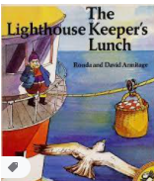  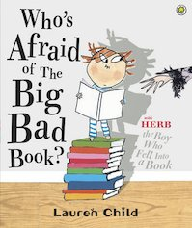 | 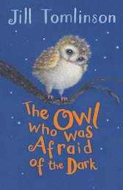  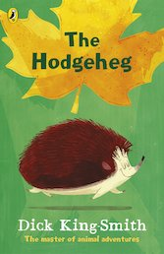 | 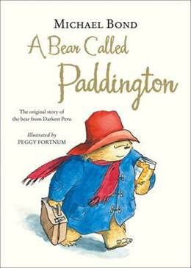  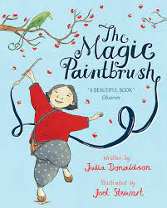 | 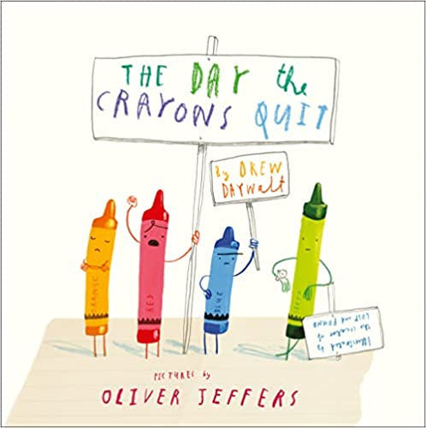  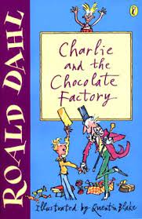 | 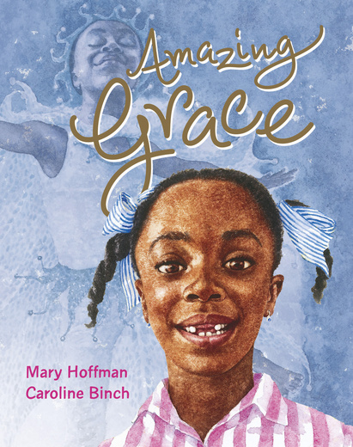  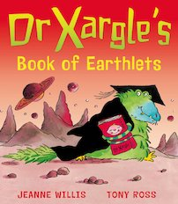 | 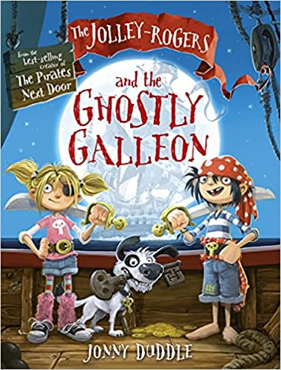  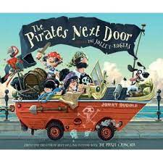
Science | Living things and their Habitats- The Local Environment  Explore and compare the difference between things that are living, dead and things that have never been alive.-life processes  Identify that most living things live in habitats to which they are suited  Seasonal Change  Observe changes across the four seasons.  Observe weather associated with the seasons and how day length varies. | Living things and their Habitats- Across the World  Find out about and describe the basic needs of animals including humans for survival (water,food,air  links to ecology, plastic waste  Identify and name a variety of plants and animals in their habitats.  Simple food chains. | Uses of Everyday Material  Identify and compare the uses of a variety of everyday materials  Find out how the shapes of solid objects can be changed by squashing, bending,twisting and stretching | Animals Including Humans  Notice that animals, including humans have offspring which grow into adults.  Seasonal Change  Observe changes across the four seasons.  Observe weather associated with the seasons and how day length varies. | Plants  Name a variety of common garden and wild plants.  Identify and describe basic structure of a variety of common flowering plants, including trees.  Observe how seeds and bulbs grow into mature plants  Find out and describe how plants need water, light and a suitable temperature to grow and stay healthy.  Seasonal Change | Animals Including Humans  Describe the importance for humans of exercise, eating the right amounts of different types of foods and hygiene.
Seasonal Change
History | Visual wall timeline. Key events and people will be placed upon the timeline throughout the academic year as they are introduced to the children.  Events beyond living memory/ Lives of significant individuals in the local area - The Grace Darling Story | Guy Fawkes  Remembrance Sunday |  | The Roald Dahl story | Key events of the great fire of London  Why the fire spread and how it was stopped.  Explain that we know about the great fire - linked to Samuel Peeps diary.  Queen Elizabeth Jubilee.  Kings and Queens timeline. | Events beyond living memory that are significant nationally or globally- The Golden Age of Piracy  Life onboard ship  Pirate code  Blackbeard  Mary Read  How do we know about pirates?
Geography | The local area  Fieldwork- trip to Marden Quarry - following the route on a map.  Journey to school devise a simple map using basic symbols in a key  home/school address  Human and Physical features of our local area  Using maps and aerial photographs  Google maps | Name, locate and identify characteristics of the four countries and capital cities of the UK and it’s surrounding seas.  Use maps, atlases and globes  Identify seasonal and daily weather patterns in the UK and  Hot and cold places areas of the world- equator, North and South Poles (linked to Science animal studies)  Using world maps, atlases and globes.  Use basic geographical vocabulary. | Understand geographical similarities and differences through comparing and contrasting the human and physical geography of Whitley Bay/Tokyo  Study Japan’s human and physical geography.  Mount Fuji  Earthquakes |  | Countries and capitals of the Uk with specific focus on London and surrounding area.  River Thames | Name and locate the seven continents and 5 oceans of the world.  Compass Directions NESW  Use locational and directional language to describe the location of features and routes on a map.  Using maps and globes  Devise simple maps with basic symbols and keys.
Art | Kapow Primary  Art and design Skills  Introducing Sketchbooks  Drawing -Shading  Learning about drawing for fun  Formal Elements  Tone 1-3D Pencil Drawings  Tone 2 -3D colour drawings  Collage - stormy seascapes | ICT- and introduction to animation  Christmas Cards  Calendars- endangered species | Kapow Primary  Formal Elements  Pattern- Repeating Patterns  Texture 1-Taking Rubbings  Texture 2-Frottage  Origami  Great wave of Kanagawa- Hokusai  kimono designs  calligraphy - hiragana | Kapow Primary  Art and design Skills  Developing painting skills- roller coaster ride  Clay-Making a clay tile/pot  craft weaving  Painting/design- Clarice Cliff plates  watercolours- Quentin Blake | Kapow Primary  Sculpture and Mixed Media  Superhero figures- using wire and plasticine to turn drawings into 3D form.  Drawing expressions -Looking at emojis  Roy Lichtenstein- class creation comic superhero art. Mixed media.  Multimedia Superhero1 - Multimedia Superhero 2  Multimedia Superhero 3 | Kapow Primary  Human Form  Human alphabet- body sculptures  Skulls- Damien Hirst. trace and decorate skulls  Julian Opie style portraits  Making faces-collage face composition.  Clothes pes figures- Edwina Bridgeman
DT |  | Delightful Decorations  Assemble, join, combine materials to make a product.  Use basic sewing techniques.  Evaluate against criteria  Identify possible changes - identify what they like/dislike. |  | Perfect Pizza  Can sort foods into food groups  Discuss different foods - healthy non healthy  Cutting skills - select tools  weighing/measuring/scoring  Generate ideas drawing on experiences  Make drawings and label parts  Evaluate against criteria |  | Identify different types of boats  working pulleys  Choose appropriate materials  Follow a design to create a boat  Evaluate against criteria  Identify possible changes - identify what they like/dislike
Computing | Writing in different styles  A unit to introduce children to word processing and desktop publishing using a number of different tools and design tasks  Writing for different audiences - Tourist Brochure 2Publish  e.g. Newspaper page, postcard, Comic Strip eSafety | An introduction to Animation  A unit that introduces both 2D animation and stop frame animation and different tools for creating both  I- motion  2Animate, | Finding and presenting information  A unit that introduces children to the web browsers to explore and search websites safely, collecting and presenting information in graphs, and different ways of sorting and classifying data with databases  eSafety | Programming with Scratch Junior  A unit where children create and debug simple programs, programme movement and appearance of an on-screen sprite and use reasoning to predict the behaviour of simple programs. Students design and program their own maze game.  eSafety | Programming with Logo -  A unit that builds on programming experiences with directions and introduces the written programming language of Logo. Students programme their on-screen robot to move and create drawings using repeat commands and their own procedures  eSafety | Beginning to present  A unit that introduces students to making interactive linear and nonlinear presentations  2Create - basic presentation  eSafety
PE | Games Unit 1  Throw and Catch  SAQ | Games Unit 2  Creative Making  Gymnastics | Games Unit 3  Dribble Hit Kick  Y2 Unit 1/2/3  Dance | Games Unit 3  Dribble Hit Kick  Skipping | Athletics unit 1  OAA | Athletics unit 2
Music/ Sing Up | Hands, Feet, Heart  Find the pulse  South Africa  Clap rhythms  Create rhythms  name simple instruments  sing in groups  Play instrumental parts  compose and perform a simple melody  Perform and share | Ho Ho Ho  Find the pulse  Explore Rap  Name instruments  March to the pulse  Clap rhythms  Explore pitch  Play instrument parts  Sins a rap together  improvise  Perform and share | I Wanna Play In A Band  Find the pulse  Explore Rock music  Name instruments  March to the pulse  Copy and clap back rhythms  Play accurately in time  Improvise  Compose a melody using simple rhythms  Perform and share | Zootime  Find the pulse  Explore Reggae music  Name instruments  Copy and clap back rhythms  Explore high and low sounds  Sing and dance together  Play accurately in time  Improvise  Compose a simple melody  Perform and share | Friendship Song  Find the pulse  Name instruments  Copy and clap back rhythms of their name  Explore high and low sounds  Sing and dance together  Play accurately in time  Improvise  Compose a simple melody  Perform and share
PSHCE | Being me in my world  Hopes and fears for the year  Rights and responsibilities  Rewards and consequences  Valuing contributions  Choices  Recognising feelings | Celebrating differences  Gender stereotype assumptions  Understanding bullying  Standing up for yourself and others  Making new friends  Gender diversity  Celebrating differences and remaining friends | Dreams and Goals  Achieving realistic goals  Perseverance  Learning strengths and learning with others  Group cooperation  Contributing to and sharing success | Healthy me  Motivation  Healthy choices  Relaxation  Healthier eating and nutrition  Healthier snacks and sharing food | Relationships  Different types of family  Physical contact boundaries  Friendship and conflict  Secrets  Trust and appreciation  Expressing appreciation for special relationships | Changing me  Life cycles in nature  Growing from young to old  Increasing independence  Difference in male and female bodies (correct terminology)  Assertiveness  Preparing for transition
RE | Judaism  The Torah  Rules and Laws  10 Commandments  Shabbat  Creation Story  Special clothes  The Synagogue  Hanukkah | How and why is light important to Christians?  Symbols of light and dark  Christingle  Significance of lighting a candle | Why is The Bible special to Christians?  Old and New Testament stories  Noah’s Ark  Daniel and the lion  Moses-linked to Judaism  David and Goliath  Jonah and the Whale | How do Christians celebrate Easter?  St Cuthbert local faith communities.  Visit to St Peter’s Church | How do Buddhists show their belief?  Meditation  special clothing  Shaved head  Alms bowl

